Brian Engel

Corner Grocer Item Tracker

Designed the class to use a private map in the class as suggested. It seemed the easiest way to access the information and not have to worry about two different vectors.

All the functions in the class are public so that main can access them since they are all just different ways of inputting or outputting the information.

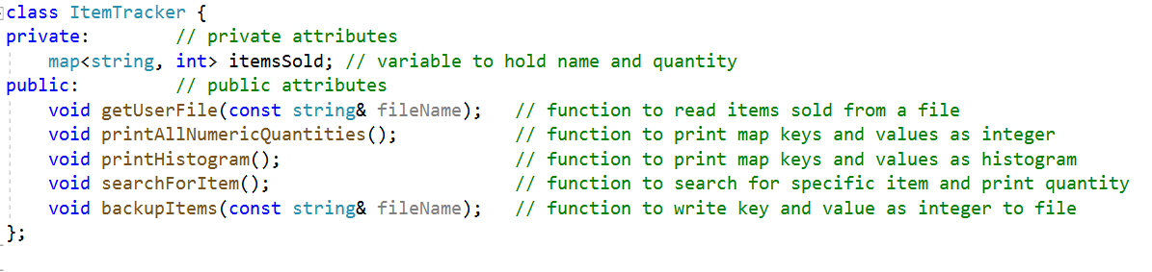

Main has its own set of functions that are not directly related to the class, and I felt they would just make the class less readable.

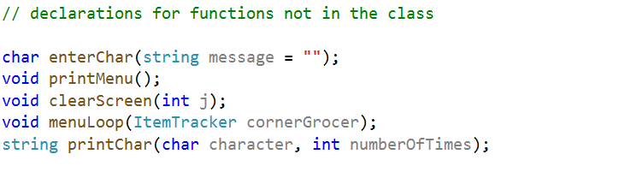

Main is short and to the point. I added variables for the input file and output file so if the files need to be changed you can just change it in one place.

